Module 15: Advanced Storytelling Techniques

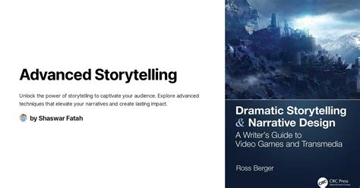
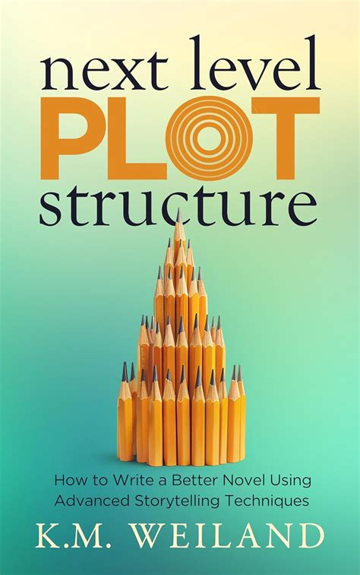
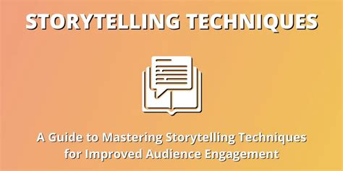

Module Metadata: Advanced Storytelling Techniques (1 Hour)
Short Description
At this stage, a storyteller has mastered the craft, developed a unique style, and built a vast repertoire of stories to choose from. They can seamlessly adapt to various storytelling contexts, including corporate, educational, and entertainment settings. Advanced storytellers captivate audiences effortlessly, incorporating humor, rhythm, and emotional depth into their delivery.
Elevate your storytelling to professional mastery. This module explores advanced techniques in rhythm, audience connection, and format experimentation — empowering storytellers to adapt across contexts and innovate with style.
Long Description
At this stage, storytelling becomes second nature — a fusion of craft, confidence, and creativity. In this module, learners refine rhythm, pacing, and tone to shape emotional journeys. They deepen audience connection through authenticity, interactivity, and emotional resonance. And they experiment with formats — from visual and multimedia storytelling to hybrid performances — expanding their repertoire for corporate, educational, and entertainment settings. This module prepares learners to lead with story, innovate with impact, and build storytelling ventures that resonate across platforms and cultures.
Aims
- To refine advanced storytelling techniques for emotional impact and audience engagement.
- To explore diverse storytelling formats and performance styles.
- To prepare learners to adapt storytelling for professional, cultural, and entrepreneurial contexts.
Objectives
By the end of this module, learners will be able to:
- Apply rhythm, pacing, and tone variation to enhance storytelling delivery.
- Build deeper audience connection through structure, authenticity, and emotional appeal.
- Experiment with visual, multimedia, and hybrid storytelling formats.
- Reflect on how advanced techniques support storytelling careers and creative enterprise.
Learning Outcomes
Learners will:
- Demonstrate mastery of storytelling techniques in live or recorded performance.
- Apply advanced strategies to engage, move, and inspire audiences.
- Create stories using diverse formats and delivery styles.
- Position themselves as professional storytellers ready to lead, teach, and innovate.

Refining Rhythm and Variation
Rhythm and variation shape the flow of a story, ensuring it remains engaging and dynamic.
- Sentence Variation – Mixing short and long sentences creates a natural rhythm.
- Pacing Control – Adjusting speed and pauses builds suspense and emotional impact.
- Repetition for Emphasis – Reinforces key themes and makes stories more memorable.
- Tone Shifts – Alternating between serious and humorous moments keeps audiences engaged.
Example: A storyteller slows down during an emotional moment and speeds up during an action-packed scene to enhance impact.
Enhancing Audience Connection
A great storyteller builds a deep connection with their audience through engagement techniques.
- Strong Story Framework – A well-structured story keeps listeners invested.
- Interactive Elements – Asking questions, involving the audience, and using call-and-response techniques.
- Authenticity & Relatability – Sharing personal experiences makes stories more impactful.
- Emotional Appeal – Stories should evoke emotions that resonate with the audience.
Example: A storyteller pauses after a dramatic moment, allowing the audience to react before continuing.
Experimenting with Different Storytelling Formats
Advanced storytellers explore diverse formats to enhance their storytelling.
- Visual Storytelling – Using images, gestures, and props to reinforce narratives.
- Multimedia Integration – Incorporating videos, music, or digital elements.
- Nonlinear Storytelling – Breaking traditional structures to create unique experiences.
- Hybrid Formats – Combining spoken word, poetry, and performance art.
Example: A storyteller uses a drumbeat to set the rhythm of a suspenseful tale.
Exercise: Experiment with voice modulation and pacing to enhance emotional delivery in a short passage.
Assignment: Perform a story using advanced techniques such as rhythm, audience engagement, and vocal variation.

